**Create an application which contains login, registration and CURD operations with following requirements**.

1. In Home page should contain two text fields (email id and password), login and registration button.
2. Did 2 pages for login and registration including validation .
3. On click registration, redirect to registration page which contains First Name, Middle Name, Last Name, Email, Mobile Number, Password, Confirm Password and Register Button.
4. All are done along with mandatory fields except
5. After successful registration of user redirect to login page.
6. Done please check.
7. Validate user with email id as [user@gmail.com](mailto:user@gmail.com) and password as 123456.
8. Done login with above given names.
9. After successful login, redirect to manage users dashboard page where CURD operations to be performed as shown in below figure.
   * 1. 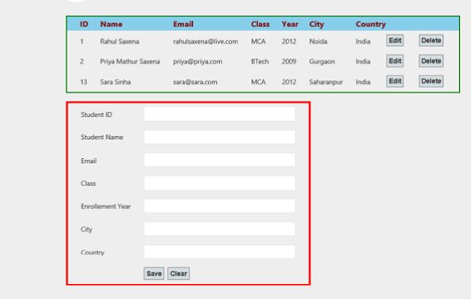
10. DONE used php for curd operations and mysql for database all these can be seen in user details page.
11. All operations to be implemented in single page (Display, Add, Edit and Delete) with form validations.

A)Done using ajax and php.

1. On Click Edit button, get all the respective values in the form and perform Edit operation.
2. **Done by entering values using ID of user and it can be easily loaded and later updated.**

**Ajax button is provided please enter and see the changes done.**

**Validations**:

* Validation required for email Id, mobile number, Password and Confirm Password.
* Password and confirm password should be same.
* While signup all fields are mandatory except Middle Name and Mobile Number.
* While Login email id and password should be mandatory.

A)All the validations are done using JS and HTML.

**Note:- I have used XAMPP. Please upload the database given or view table structure pic.**

**Deliverables**:

* After completion of assignment, check-in the code to Github and share the link to the repository.

**Notes:**

* If you are not clear on the requirements, please feel free to draw your own assumptions and send then along with your test output.